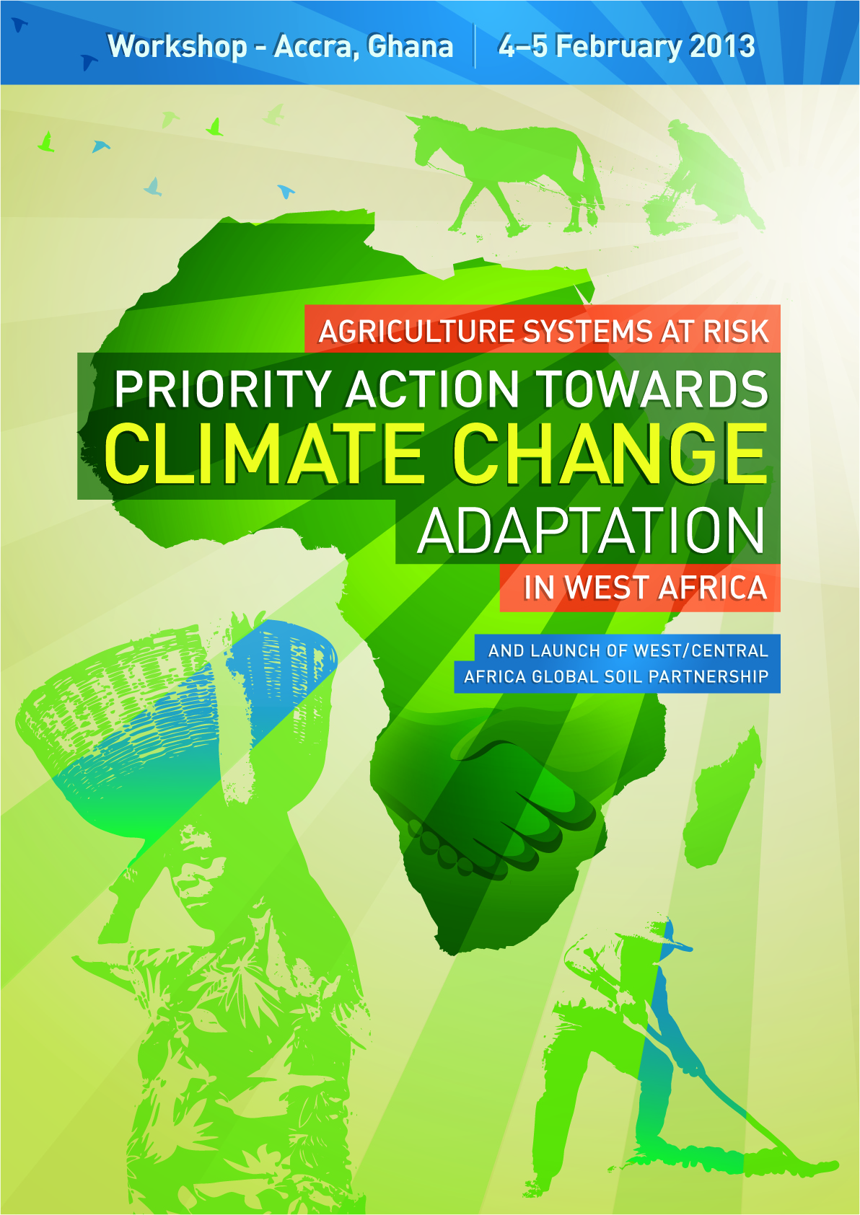

WORKSHOP AGENDA
Labadi Beach Hotel Accra, Ghana

Sunday 3rd February 2013

4.00pm- 6.00pm Registration
(Labadi Hotel conference Hall)
Ms. Gunlycke Naemi and Ms. Adjei Sibyl
DAY ONE: 4th February 2013
Session I | Workshop official opening  Chairperson: Mr. Boroto Ruhiza  Rapportour: Mr.Seydou Tinni
08:30 – 09:15 | Opening session  - FAO Assistant Director General Ms. Maria Helena Semedo  - ECOWAS  - Ghana government official
09:15 – 09:45 | Key note Address Agriculture Systems at Risk: Priority Action towards climate change adaptation in West Africa by Jean Sibiri ZOUNDI member “Sahel Club”
09:45 – 10:00 | Discussions
10:00 – 10:30 | TEA-COFFEE BREAK
Session II | Regional Status:  Chair person: Dr. Timothée Ourbak  Rapportour: DeRidder Benjamin
10:30 -11:00 | State of Land and Water in West Africa by FAO Deputy Regional Representative and Sub-regional co-ordinator for West Africa
11:00 -11:30 | Vulnerability of agricultural sector to Climate Change and Variability in West Africa by CCAFS
11:30 -12:00 | Strategic sub-regional program to reduce vulnerability and enhanced adaptation to climate change in West Africa by Directorate of Environment ECOWAS
12:00 – 13:00 | Discussion
13:00 – 14:00 | LUNCH BREAK
Session III | Parallel group sessions  Overall co-ordinator: Dr. Rui Luis Silva
14:00 – 16:00 | Launch of Global Soil Partnership  Co-ordinator  Ronald Vargas  FAO | Downscaling climate information and services  Co-ordinator Robert Zougmore  Seydou Tinni  (CCAFS) | Drought management  Policies  Co-ordinator  Meshack Malo  FAO |  | Agriculture water management  Co-ordinator Herve Levite  Santini Guido  (WRCC, AGWA,IWMI) | Vulnerability of Agriculture to Climate change and Variability  Co-ordinator Timothée Ourbak  AGRHYMET
 | Parallel session details in annex 1
16:00 - 16:20 | TEA-COFFEE BREAK
Session IV  16:20 – 17:00 | Cont. GSP Launch | Group Work Presentations  Chair person:  Rappourtour: Ms Anna Tengnas
DAY TWO: 5th February 2013

Session V | On-the ground adaptation investment opportunities: Status and Opportunities in the Agriculture sector  Chairperson: Dr. Zougmore Robert  Rapportour:
08.30-09.00 | AGWA presentation
09:00 – 09:30 | Inputs from partners (SIDA, EU, USAID, GIZ, DFID, AfDB )
09:30 –10.00 | Discussions
10.00 – 10:30 | TEA-COFFEE BREAK
Session VI | Country Breakout Sessions
10:30 -12:00 | Countries priorities maximum two actions needed for future on-ground implementation at (i) country level and (ii) regional level.
Session VII  12:00 – 13:00 | Presentation of country recommendations  Chairperson: Mr. Herve Levite  Rapportour: Mr. Bamba Aliou
13:00 – 14:00 | LUNCH BREAK
14:00 – 15:00 | Country Recommendations Continues |  |  | Launch of Global Soil Partnership  (FAO)  GSP continues on 6th February 2013 (detailed agenda to be distributed)  Co-ordinator Ronald Vargas  FAO
15:00 – 16:00 | Discussions
16:00 – 16:30 | TEA-COFFEE BREAK
16:30 – 17:00 | Conclusion and way forward  By Dr. Alemneh Dejene  - Summary  - Evaluation  - Key actions  - Follow up

Annex 1: Session III Parallel Group Session
Session | Narrative | Presentations
Launch of Global Soil Partnership

Co-ordinator
Ronald Vargas
FAO

Downscaling climate information and services  Co-ordinator  Robert Zougmore  Seydou Tinni  (CCAFS) |  | - Downscaling of climate information and services in WA: making cc information more relevant to farmers by Seydou Tinni, AGRHYMET  - Prévisions climatiques saisonnières et leur application pour la gestion de l'exploitation familiale: cas des sites du programme CCAFS en Afrique de l’Ouest by Ousmane Ndiaye, ANACIM  - Tailoring climate information and services to the need of end-users : an example from Mali by Daouda Zan Diarra, Météo Mali  - Scaling up climate smart information and services in WA: challenges, opportunities and way forwards  - Discussions and Wrap up
Drought management  Policies  Co-ordinator  Meshack Malo  FAO | Drought- a natural phenomenon stemming from climatic variability - is projected to increase in frequency and intensity as a result of climate change. Drought damages encompass famine, social disruption, resources degradation and the economy at large. The conventional emergency response to drought has the limits of being ineffective and costly and increasing societal vulnerability to future drought. Pro-active national drought policies based on drought monitoring and early warning, risk assessment, and management planning are needed to effectively reduce the devastating impacts.  This session will give an overview of the process of pro-active drought risk management, followed by presentations on drought characterization and how it is currently managed in selected countries of the ECOWAS region; then plenary discussion.
Agriculture water management

Co-ordinator
Herve Levite
Santini Guido
(WRCC, AGWA,IWMI)
Vulnerability of Agriculture to Climate change and Variability

Co-ordinator Timothée Ourbak
AGRHYMET

